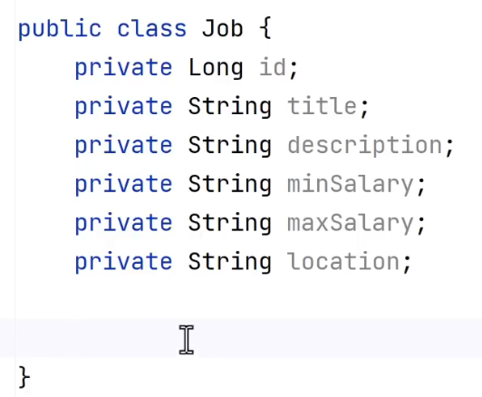

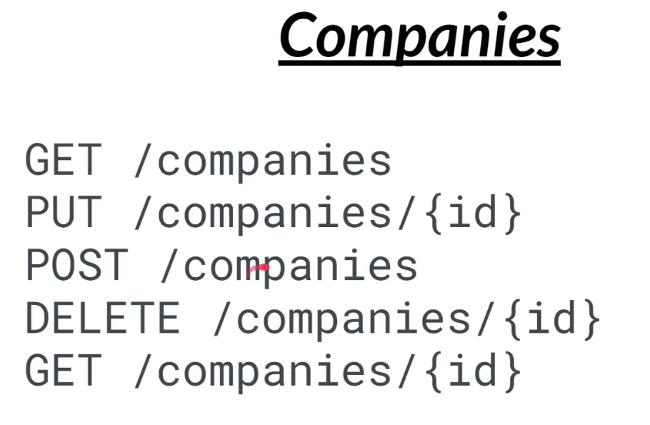

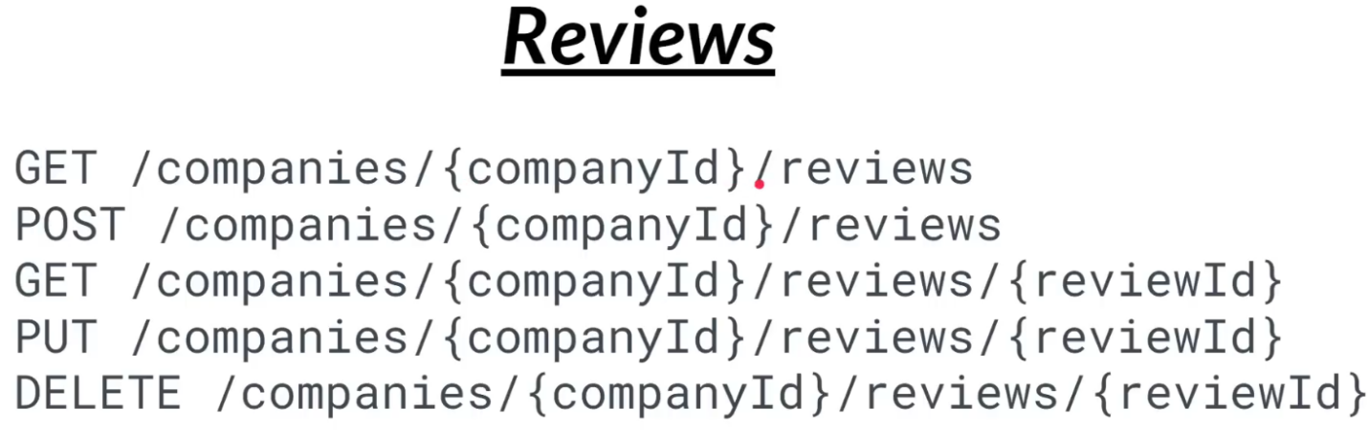

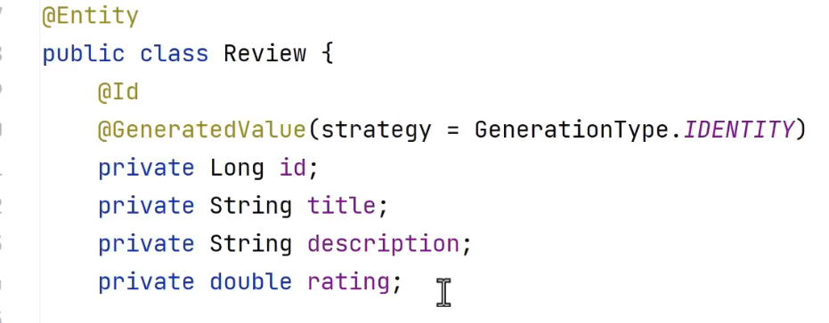

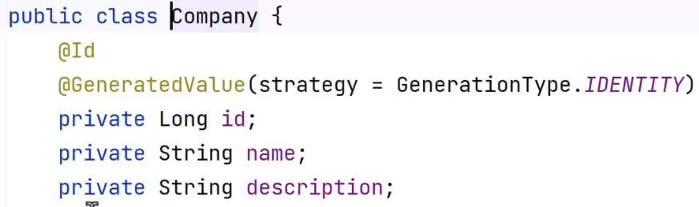

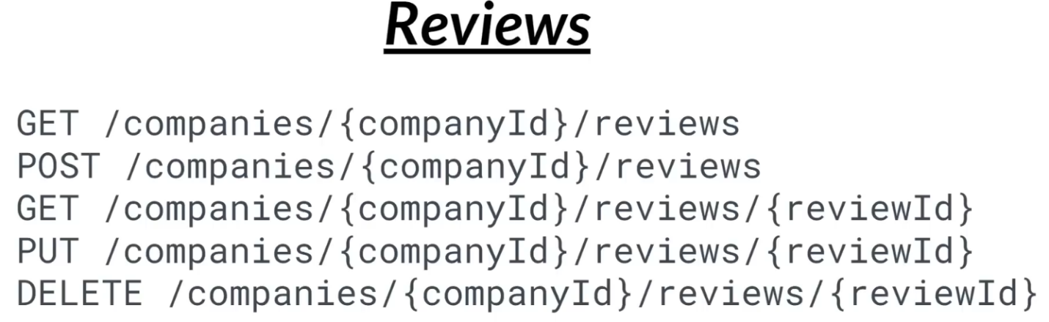

 6:25

 6:56

./mvnw spring-boot:build-image “-Dspring-boot.build-image.imageName=chetanag/companyimage”

Docker run -p 8080:8080 image

 8:53

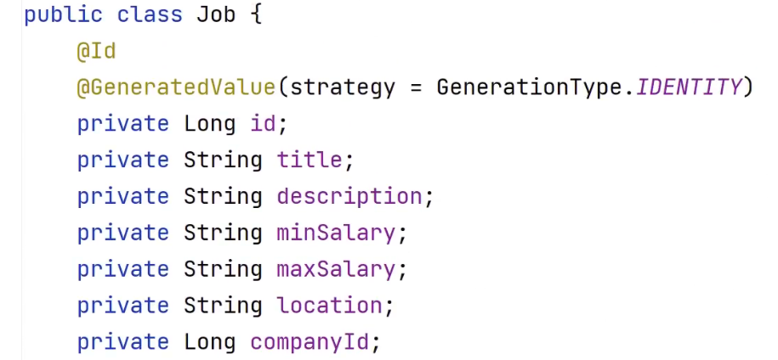

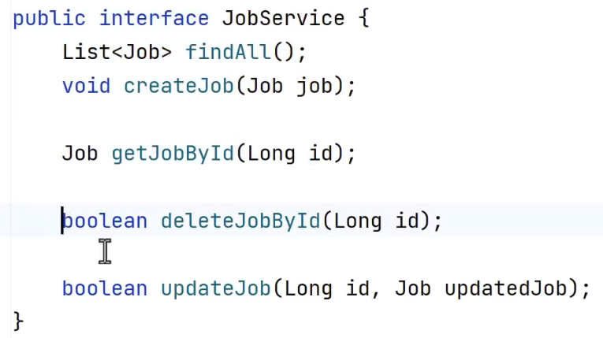

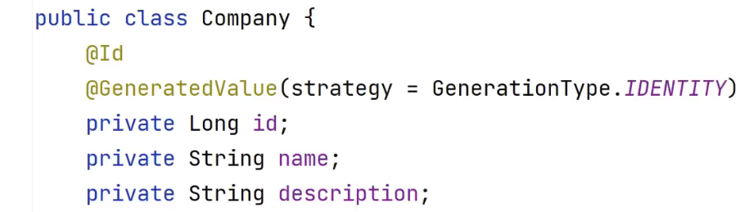

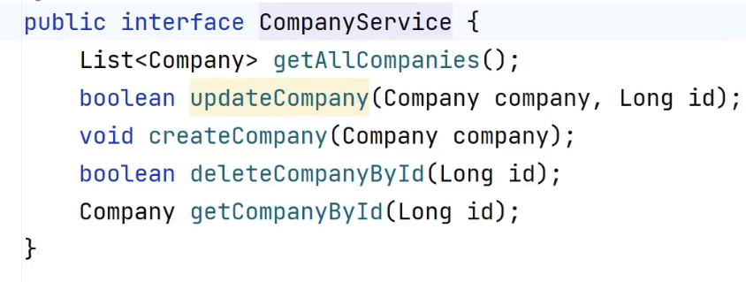

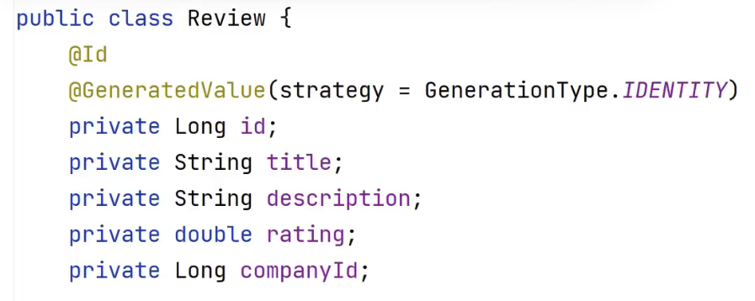

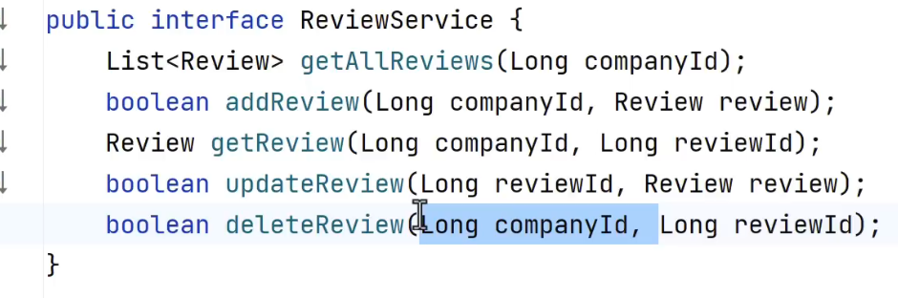

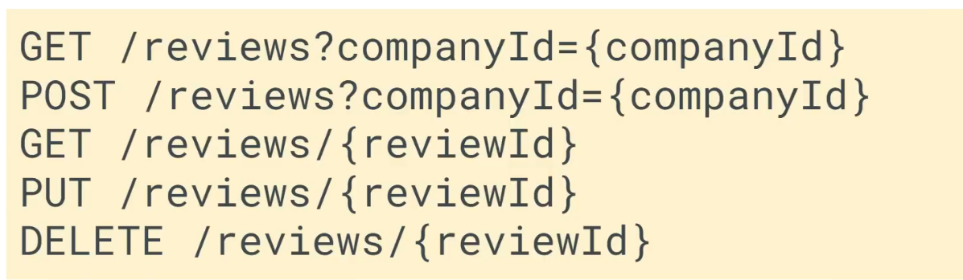

 10:36

 10:53

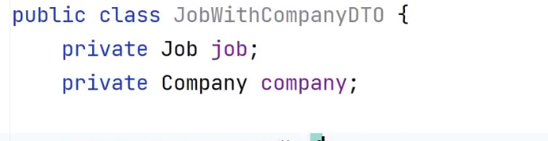

PART2



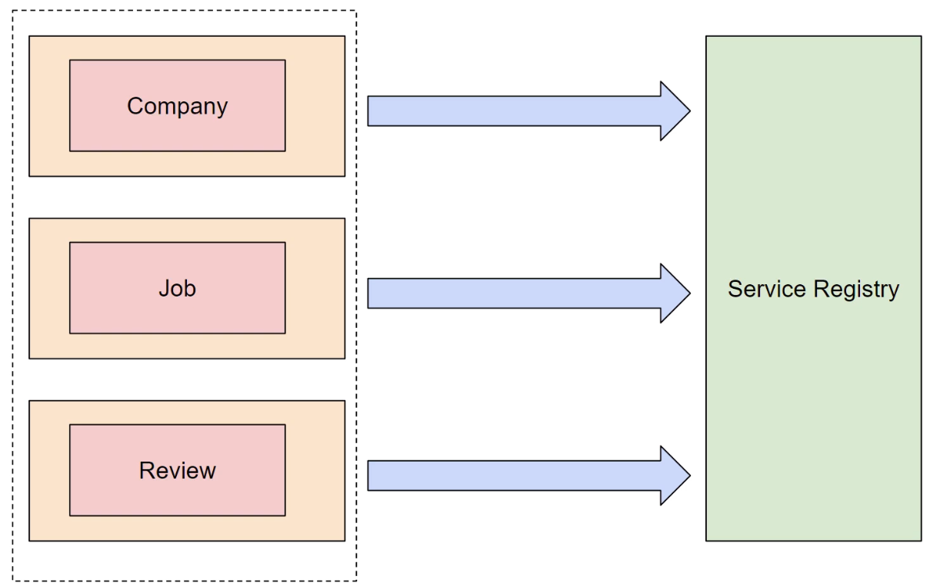

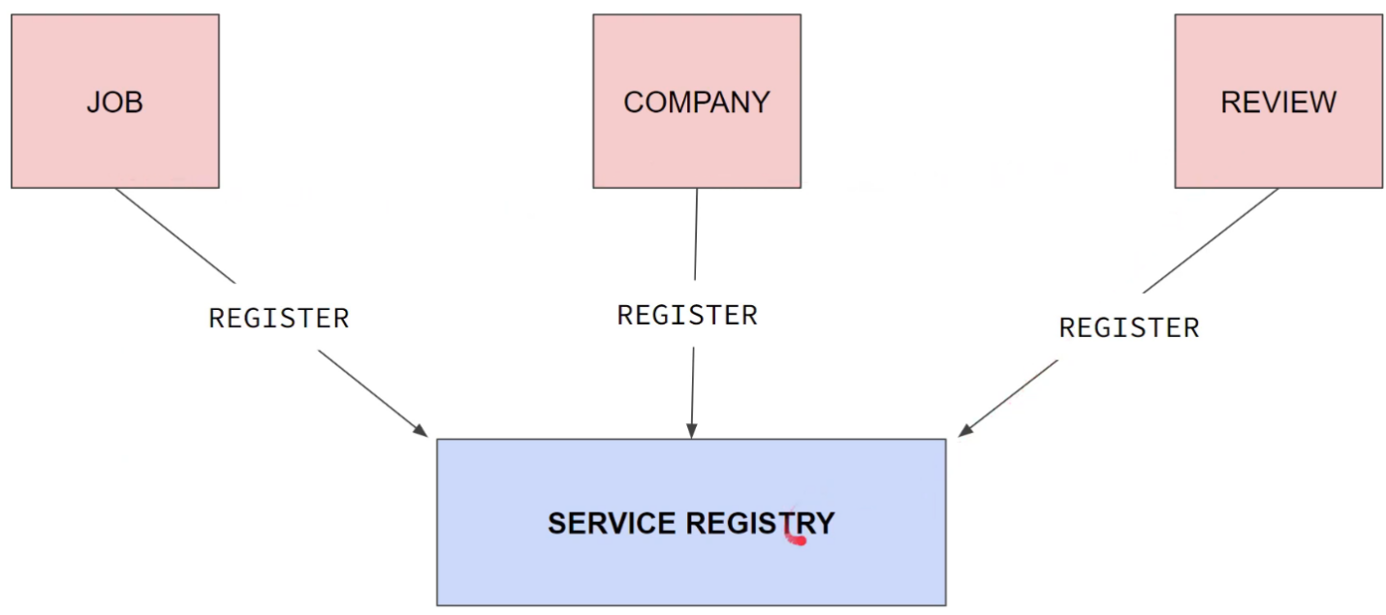

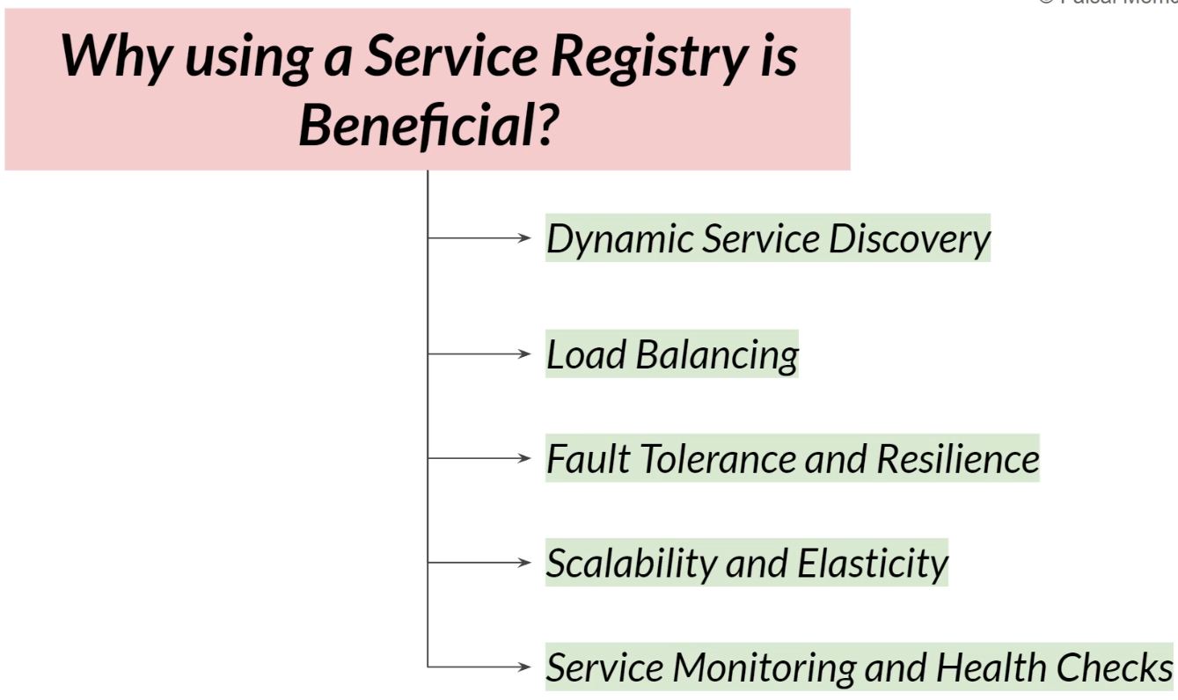



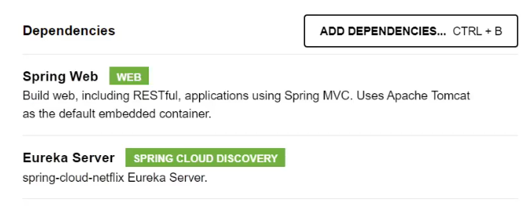

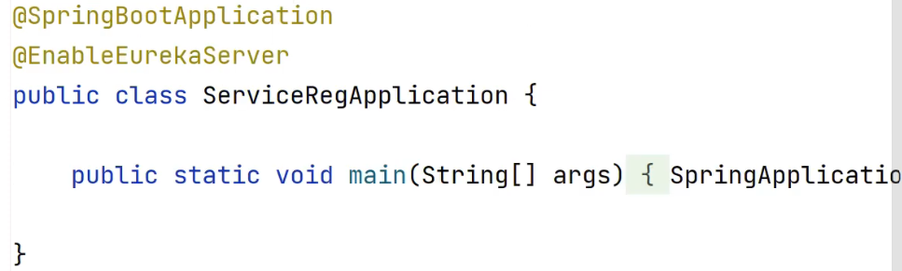

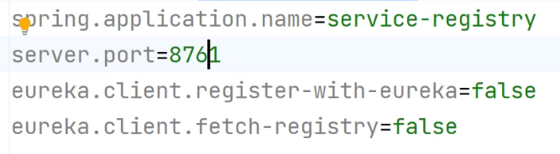

In microservices

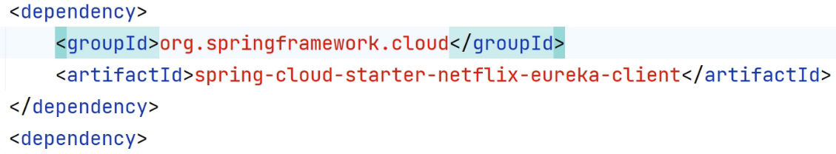

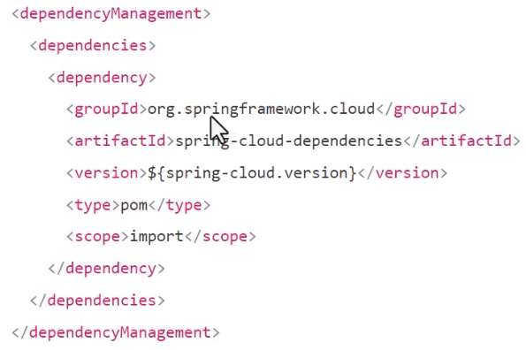



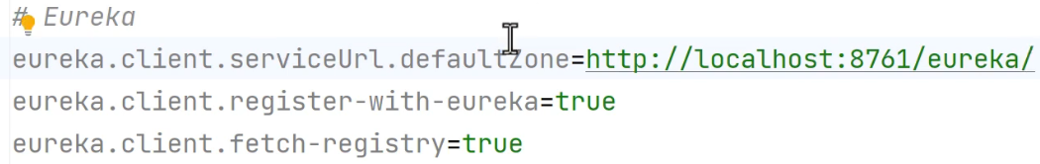

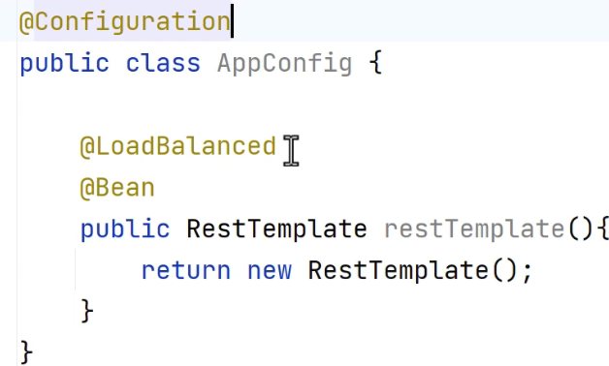

Now we can use service names

 1:34

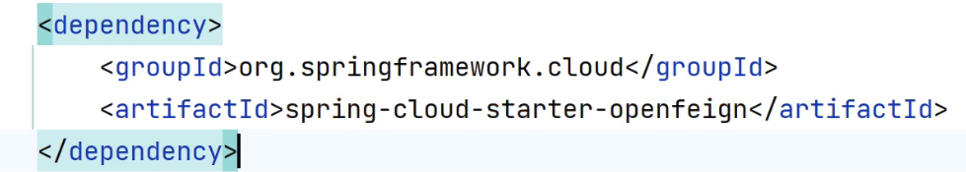

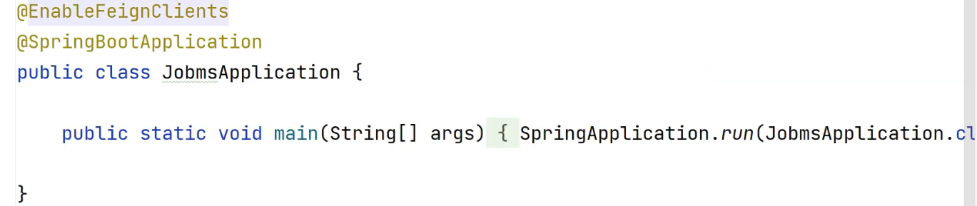

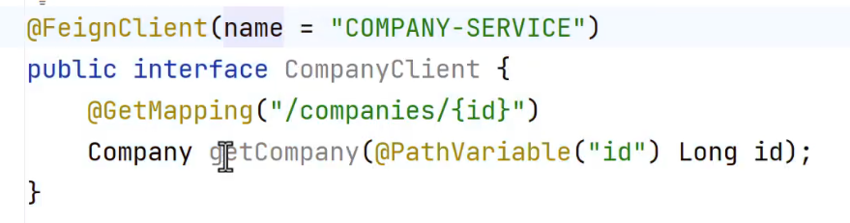



 1:56



 2:05

 2:16

 2:57

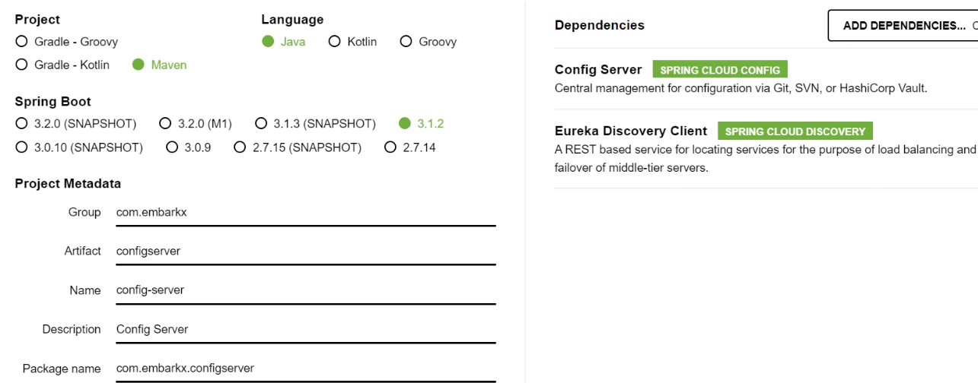

 3:45

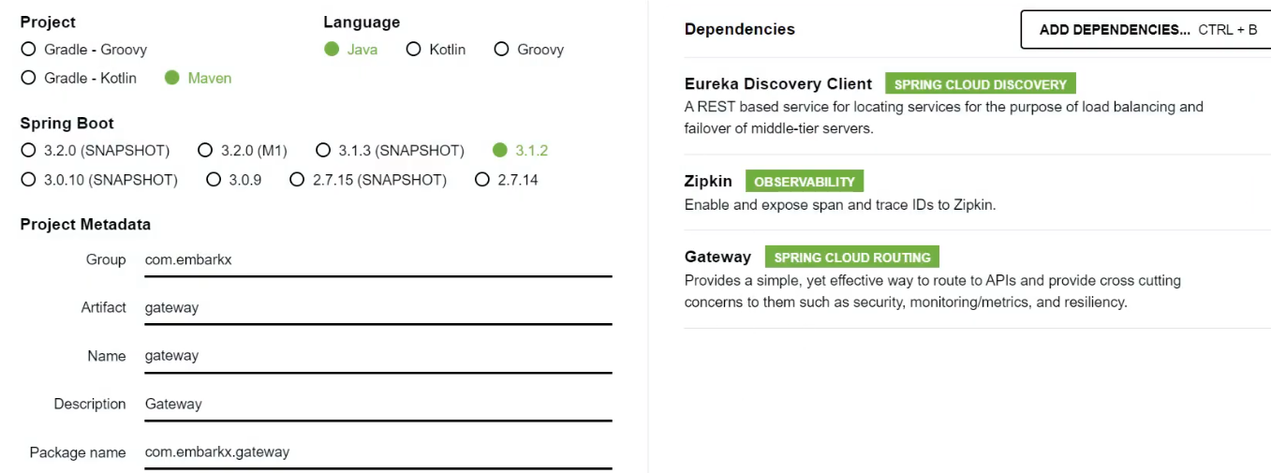

spring:  
 application:  
 name: gateway  
  
 cloud:  
 gateway:  
 routes:  
 - id: COMPANYMS  
 uri: http://localhost:8082  
 predicates:  
 - Path=/api/company/**  
 - id: JOBMS  
 uri: http://localhost:8081  
 predicates:  
 - Path=/api/job/**  
 - id: REVIEWMS  
 uri: http://localhost:8083  
 predicates:  
 - Path=/api/review/**  
  
server:  
 port: 8080  
  
eureka:  
 client:  
 fetch-registry: true  
 register-with-eureka: true  
 service-url:  
 defaultZone: http://localhost:8761/eureka

 4:32

 4:37

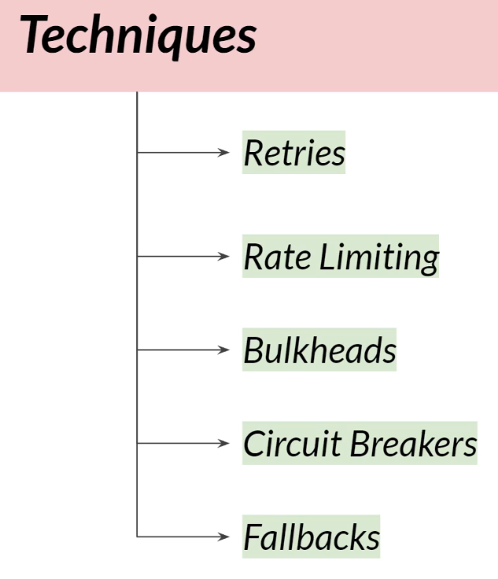

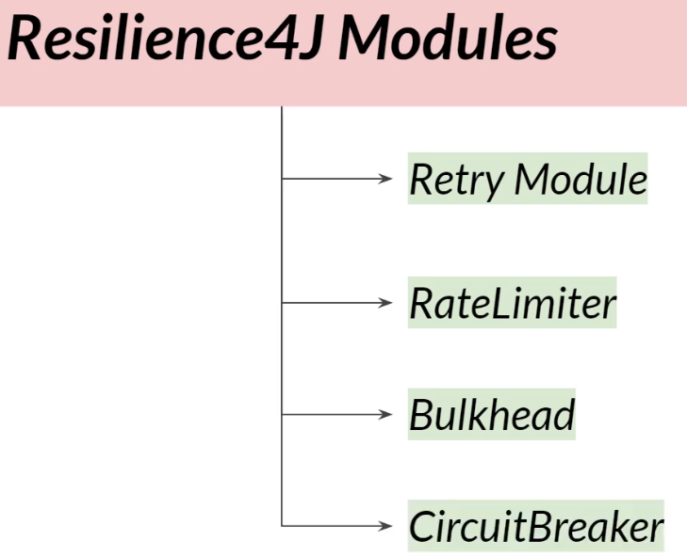

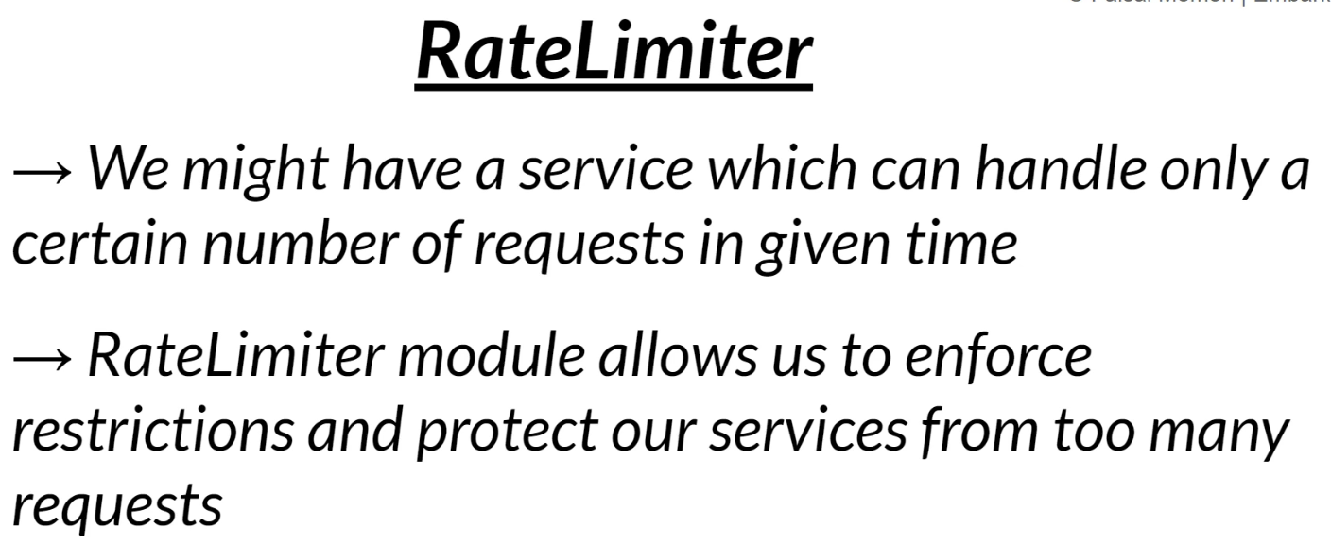

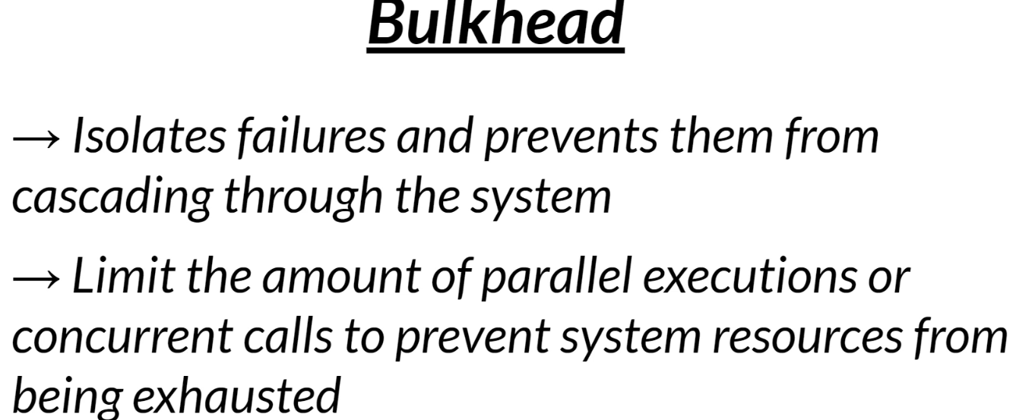

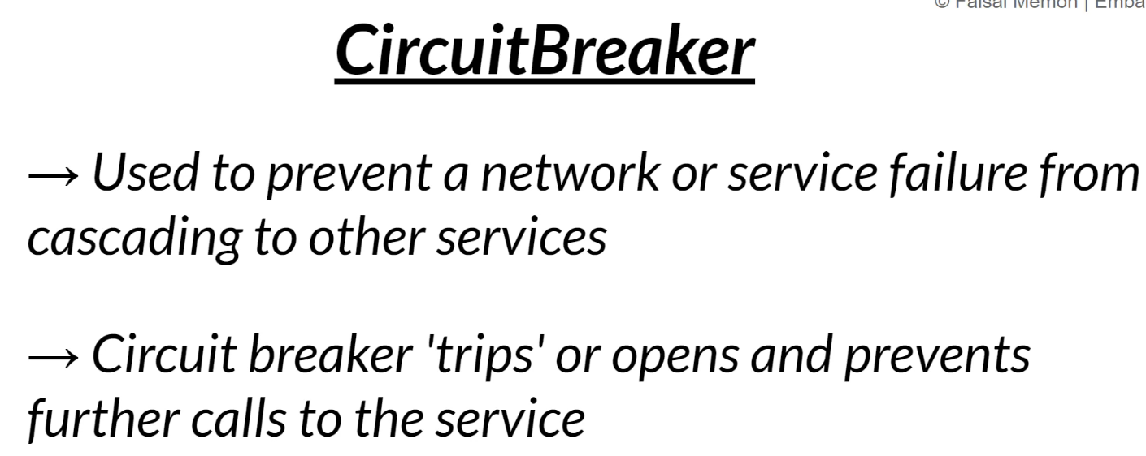

Add in jobsms

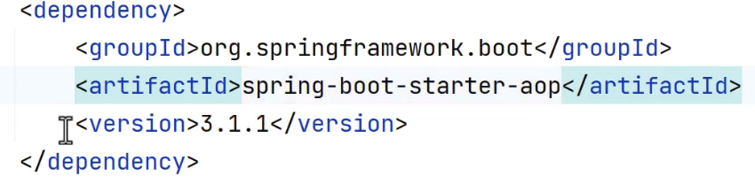

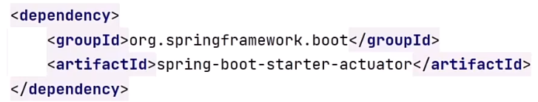

management:  
 health:  
 circuitbreakers:  
 enabled: true  
  
 endpoints:  
 web:  
 exposure:  
 include: health,info,metrics,loggers,threaddump  
  
 endpoint:  
 health:  
 show-details: always  
  
resilience4j:  
 circuitbreaker:  
 instances:  
 companyReviewResponse:  
 registerHealthIndicator: true  
 event-consumer-buffer-size: 10  
 failure-rate-threshold: 50  
 minimum-number-of-calls: 5  
 automatic-transition-from-open-to-half-open-enabled: true  
 wait-duration-in-open-state: 6s  
 permitted-number-of-calls-in-half-open-state: 6  
 sliding-window-size: 10  
 sliding-window-type: count_based

 6:21

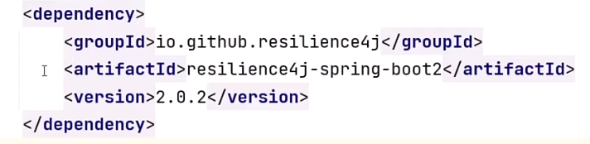

 5:44

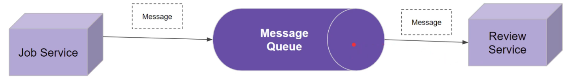

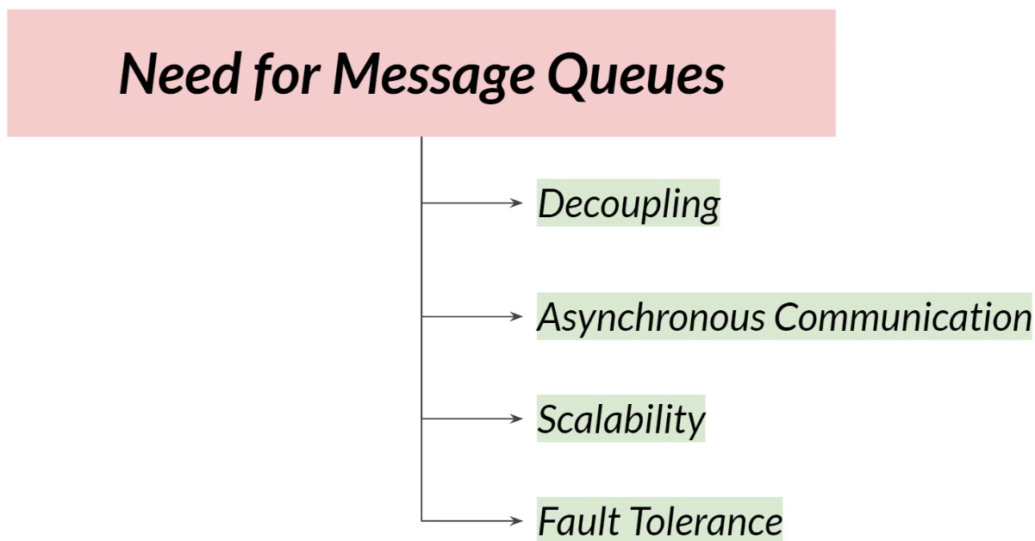

 6:02

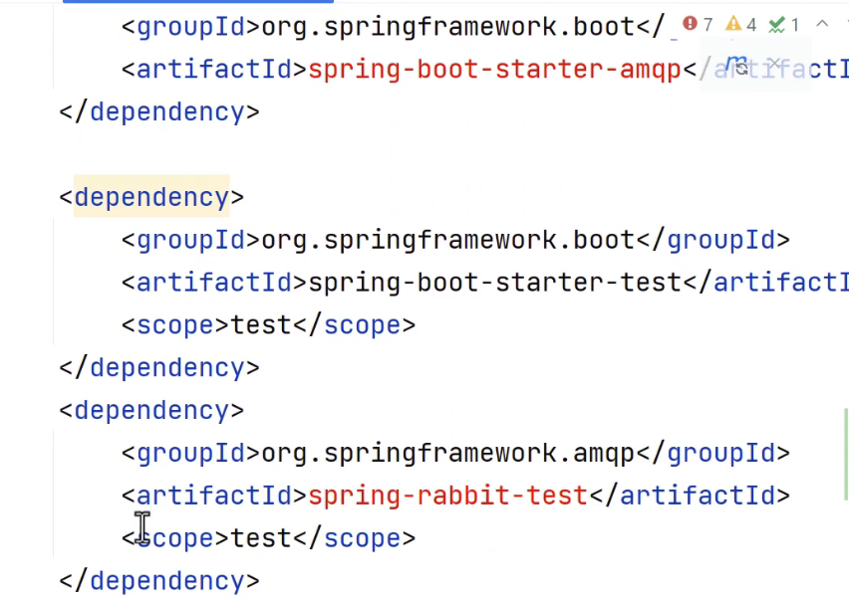

Add dependency in responding services like company and review

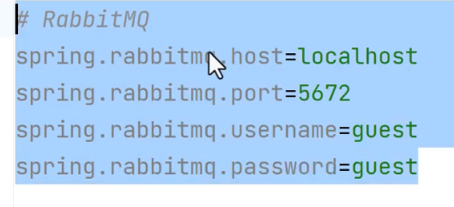

Here Reviewms produces message and compay consumes it.

In reviewms

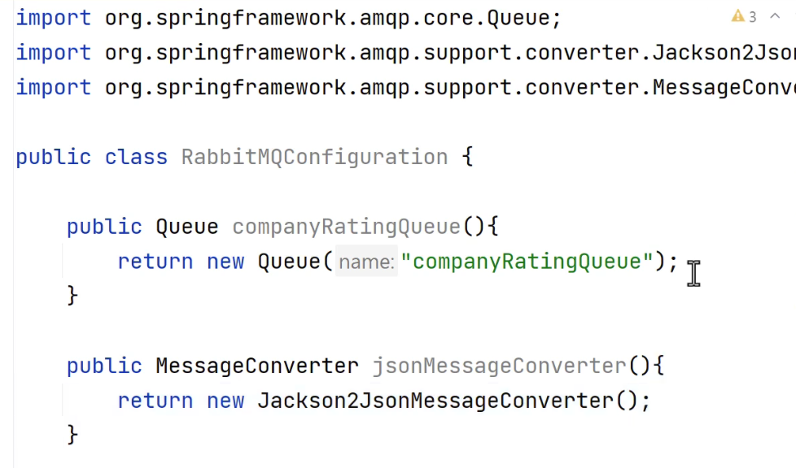

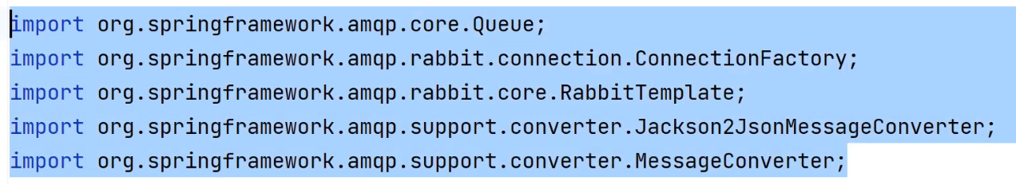

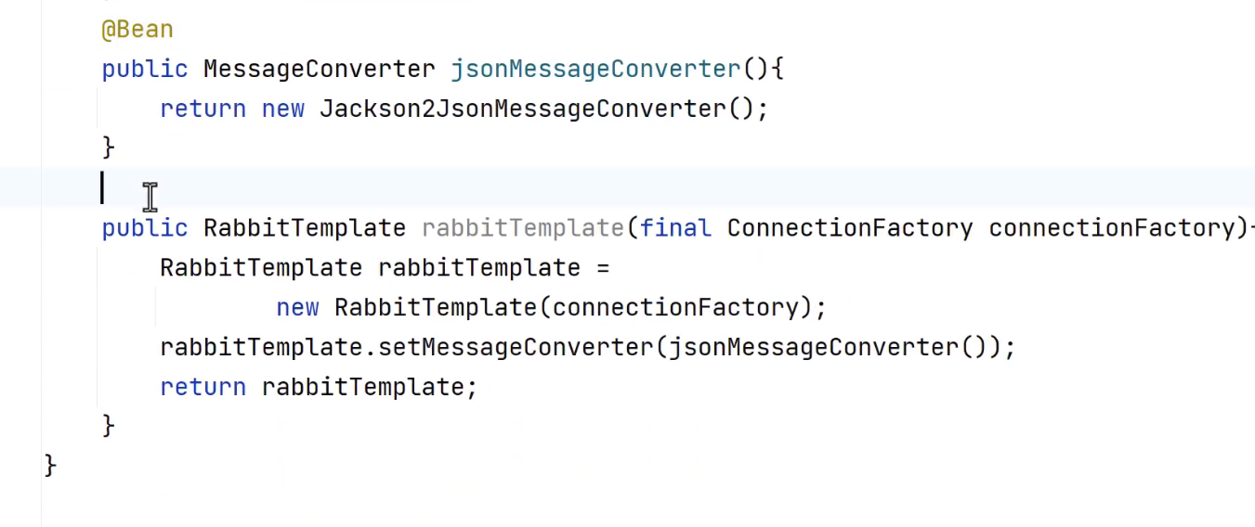

Make clsass @Configuration

DTO

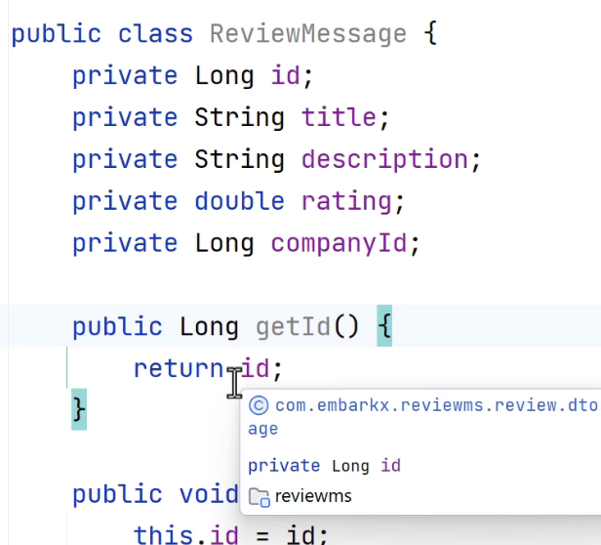

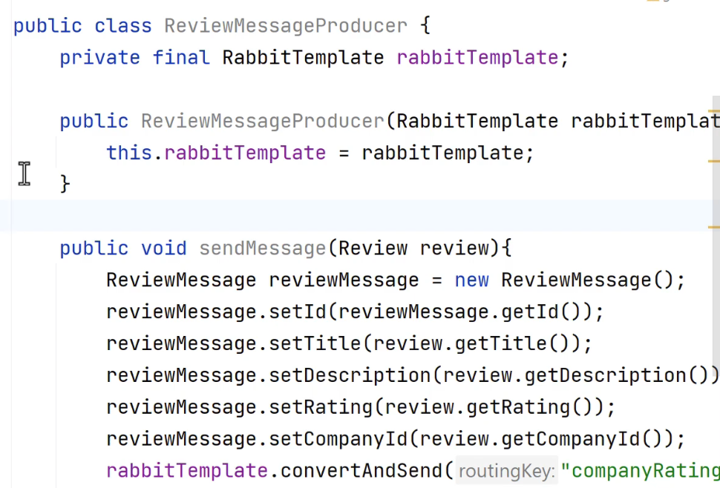

Create configuration class in acomsumer also

Docker

./mvnw spring-boot:build-image "-Dspring-boot.build-image.imageName=chetanag/jobpackage"

docker push chetanag/jobpackage

Create docker-compose.yml in pom.xml level

version: '3.8'  
  
services:  
 mysql:  
 image: mysql:8  
 environment:  
 MYSQL_ROOT_PASSWORD: Chetan@902  
 MYSQL_DATABASE: bank  
 ports:  
 - "3306:3306"  
  
 jobapp:  
 image: chetanag/bankpkage  
 ports:  
 - "8080:8080"  
 environment:  
 SPRING_DATASOURCE_URL: jdbc:mysql://mysql:3306/bank  
 SPRING_DATASOURCE_USERNAME: root  
 SPRING_DATASOURCE_PASSWORD: Chetan@902  
 depends_on:  
 - mysql

Stop mysql in local

docker-compose up -d

If something goes wrong

# Stop and remove containers

docker-compose down

# Rebuild image

./mvnw clean package

./mvnw spring-boot:build-image -Dspring-boot.build-image.imageName=chetanag/jobpackage

# Start containers

docker-compose up -d

Test application